
Information & Security lab - 251L
Muhammad Talha
Section

CS.3ndB
Registration NO:
UW-24-CS-BS-101
UNIVERSITY OF WAH(UOW)

DEPARTMENT OF COMPUTER
SCIENCE

COURSE:

SUBMITTED TO:

Ms. Wasifa Kanwal
SUBMITTED BY:

Lab Task # 04
Task # 01
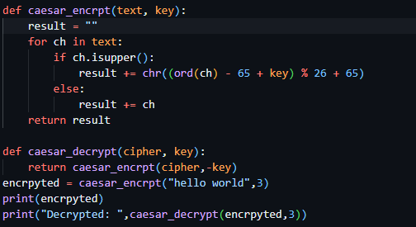
Output
Code
def caesar_encrpt(text, key):
result = ""
for ch in text:
if ch.isupper():
result += chr((ord(ch) - 65 + key) % 26 + 65)
else:
result += ch
return result

def caesar_decrypt(cipher, key):
return caesar_encrpt(cipher,-key)
encrpyted = caesar_encrpt("HELLO WORLD",3)
print(encrpyted)
print("Decrypted: ",caesar_decrypt(encrpyted,3))

Task # 02
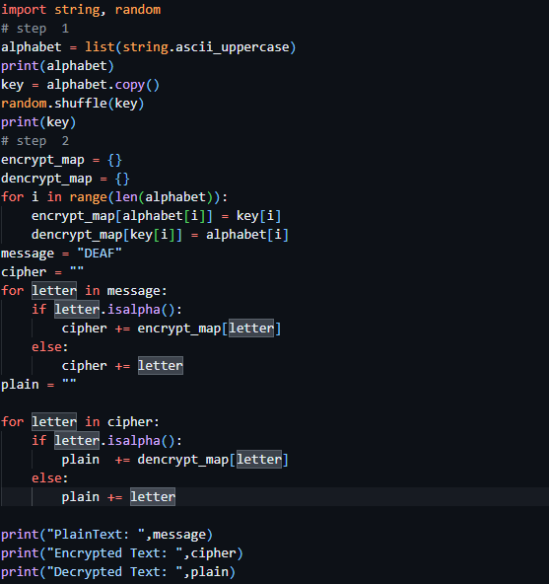
Output
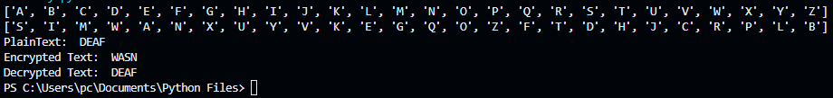
Code
import string, random
# step 1
alphabet = list(string.ascii_uppercase)
print(alphabet)
key = alphabet.copy()
random.shuffle(key)
print(key)
# step 2
encrypt_map = {}
dencrypt_map = {}
for i in range(len(alphabet)):
encrypt_map[alphabet[i]] = key[i]
dencrypt_map[key[i]] = alphabet[i]
message = "DEAF"
cipher = ""
for letter in message:
if letter.isalpha():
cipher += encrypt_map[letter]
else:
cipher += letter
plain = ""

for letter in cipher:
if letter.isalpha():
plain += dencrypt_map[letter]
else:
plain += letter

print("PlainText: ",message)
print("Encrypted Text: ",cipher)
print("Decrypted Text: ",plain)
Task # 03
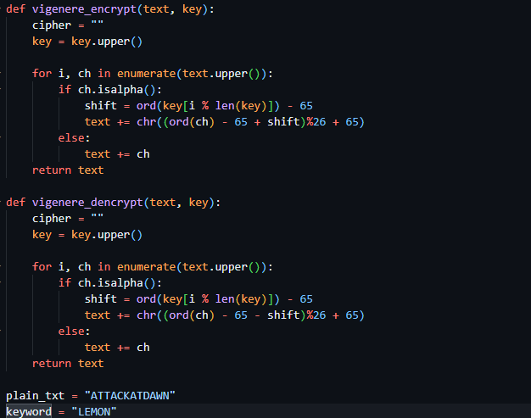

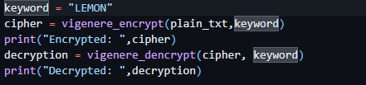
Output
Code
def vigenere_encrypt(text, key):
cipher = ""
key = key.upper()

for i, ch in enumerate(text.upper()):
if ch.isalpha():
shift = ord(key[i % len(key)]) - 65
text += chr((ord(ch) - 65 + shift)%26 + 65)
else:
text += ch
return text

def vigenere_dencrypt(text, key):
cipher = ""
key = key.upper()

for i, ch in enumerate(text.upper()):
if ch.isalpha():
shift = ord(key[i % len(key)]) - 65
text += chr((ord(ch) - 65 - shift)%26 + 65)
else:
text += ch
return text

plain_txt = "ATTACKATDAWN"
keyword = "LEMON"
cipher = vigenere_encrypt(plain_txt,keyword)
print("Encrypted: ",cipher)
decryption = vigenere_dencrypt(cipher, keyword)
print("Decrypted: ",decryption)

Task # 04
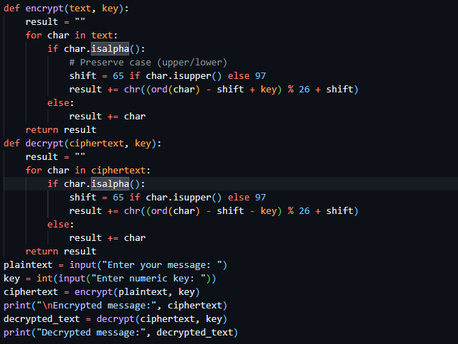
Output
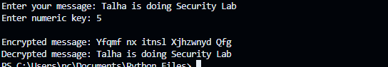
Code
def encrypt(text, key):
result = ""
for char in text:
if char.isalpha():
# Preserve case (upper/lower)
shift = 65 if char.isupper() else 97
result += chr((ord(char) - shift + key) % 26 + shift)
else:
result += char
return result
def decrypt(ciphertext, key):
result = ""
for char in ciphertext:
if char.isalpha():
shift = 65 if char.isupper() else 97
result += chr((ord(char) - shift - key) % 26 + shift)
else:
result += char
return result
plaintext = input("Enter your message: ")
key = int(input("Enter numeric key: "))
ciphertext = encrypt(plaintext, key)
print("\nEncrypted message:", ciphertext)
decrypted_text = decrypt(ciphertext, key)
print("Decrypted message:", decrypted_text)

Task # 05
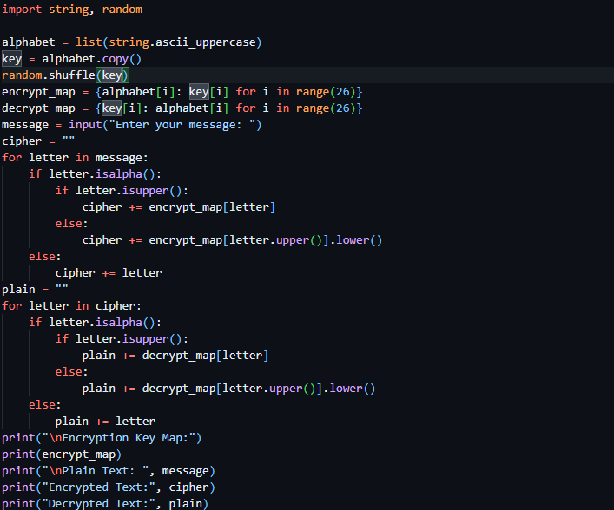
Output
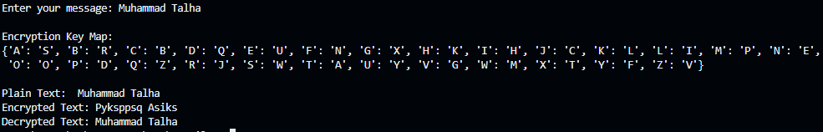

Code
import string, random

alphabet = list(string.ascii_uppercase)
key = alphabet.copy()
random.shuffle(key)
encrypt_map = {alphabet[i]: key[i] for i in range(26)}
decrypt_map = {key[i]: alphabet[i] for i in range(26)}
message = input("Enter your message: ")
cipher = ""
for letter in message:
if letter.isalpha():
if letter.isupper():
cipher += encrypt_map[letter]
else:
cipher += encrypt_map[letter.upper()].lower()
else:
cipher += letter
plain = ""
for letter in cipher:
if letter.isalpha():
if letter.isupper():
plain += decrypt_map[letter]
else:
plain += decrypt_map[letter.upper()].lower()
else:
plain += letter
print("\nEncryption Key Map:")
print(encrypt_map)
print("\nPlain Text: ", message)
print("Encrypted Text:", cipher)
print("Decrypted Text:", plain)

